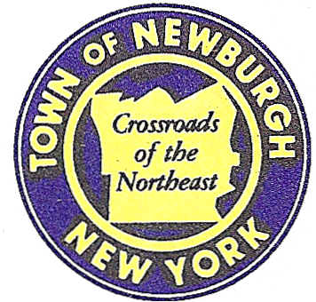

TOWN OF NEWBURGH
_______Crossroads of the Northeast __________________________
OLD TOWN HALL
308 GARDNERTOWN ROAD NEWBURGH, NEW YORK 12550

PLANNING BOARD
JOHN P. EWASUTYN, CHAIRMAN
TELEPHONE 845-564-7804
FAX 845-564-7802
E-MAIL: planningboard@townofnewburgh.org

PLANNING BOARD AGENDA

OCTOBER 1, 2015

*PLEASE NOTE: The Planning Board Meeting will start at 7:00 P.M. and all Applicants/Representatives
are to be present at that time. The Meeting will be held in the Meeting Room of Town Hall, located at
1496 Route 300, Newburgh NY.*

- NYC DEP Delaware Aqueduct Repair (2011-15)  Roundout-West Branch Tunnel  Sec. 8; Blk. 1; Lots 15.2 & 22.2  Zone: B/AR  Rep: NYC DEP  96-05 Horace Harding Exp.  Corona, NY 11368 | AMENDED SITE PLAN
- Lands of Weddell (2015-27)  6, 12, 14 and 7 Heritage Lane  Section 89, Block 1, Lots 10.1, 10.2, 77.1 & 77.2  Zone: R-1  Rep: Vincent J. Doce Associates  242 South Plank Road  Newburgh, NY 12550 | INITIAL APPEARANCE  LOT LINE CHANGE
- Dunkin Donuts (2014-02)  301 NYS Route 32  Section 14, Block. 1, Lot 43  Zone: IB  Rep: Larry Marshall, P.E.  Mercurio Norton Tarolli & Marshall  45 Main Street  Pine Bush, NY 12566 | SITE PLAN / ARB
*WORK SESSION*
Project Readiness Discussion scheduled for 5:30 p.m. in the Meeting Room of
Town Hall on Thursday, October 1, 2015.*

PLANNING BOARD BUSINESS
WORK SESSION

October 1, 2015
5:30 P.M.

Discussion:

1. Good Will Fire District - Construction of New Firehouse.

2. Domingues - Hickory Hill Road Subdivision (2011-17): The Applicant is
requesting a 90 day approval extension from October 1, 2015 to January 1, 2016.

